# CSC 430 – Database Management Systems

PRACTICE Exam 1

Name: 100 points

Instructions:

* Put your name in the appropriate place at the top of this page;
* Do not use red ink;

# Closed books and notes;

* **No electronic devices are allowed;**
* You will only receive points for a question if you attempt to answer it;
* For full credit, list all formulas that provide the basis for calculations and show all work;
* If you aren't clear about a question, state your assumptions first followed by your answer;
* When finished with the exam, read and sign the pledge at the bottom of this page.

Good luck!

“On my honor as a Louisiana Tech student, I have neither given nor received unauthorized assistance on this academic work.”

Student signature

**Section A: Multiple-choice questions.** Total: 10 points.

Please, circle a single correct option. Each question is worth 2 points.

1. Select correct statement(s):
   1. Database design stages include logical and physical design among others.
   2. Data abstraction is the concept that forces users to know how the data is physically stored.
   3. Database represents some aspects of mini-world.
   4. Database system consists solely of the DBMS software.
   5. Databases support multiple views of the data they store.
   6. All of the above.
   7. Only a, c, e.
   8. Only a, b, c.
2. Select correct statement(s):
   1. Logical data independence means that changes of conceptual schema will not force changes of external schema.
   2. Logical data independence means that changes of conceptual schema will force changes of external schema.
   3. Physical data independence means that changes of internal schema will force changes of conceptual schema.
   4. Physical data independence means that changes of internal schema will not force changes of conceptual schema.
   5. All of above.
   6. Only a, b.
   7. Only b, c.
   8. Only a, d.
3. Select correct statement(s):
   1. Every entity must have a key or have inherited a key.
   2. Relationships can be binary, ternary, or n-ary where n is greater than 3.
   3. Every value for an attribute must be unique.
   4. Attribute relates two or more distinct relationships with specific meaning.
   5. All of the above.
   6. None of the above.
   7. Only a, b.
   8. Only b, c.
4. Select correct statement(s):
   1. Schema is the set of tuples in a relation.
   2. The order of different tuples in a relation is part of the state of the relation.
   3. The total number of tuples must match the number of attributes for the relation.
   4. The values in a tuple can be composite.
   5. All of the above.
   6. None of the above.
   7. Only a, b, c.
   8. Only b, c, d.
5. Select correct statement(s):
   1. Domain constraint involves adhering to the type and format of the data for that attribute.
   2. Key constraint is violated if any primary key attribute is set to null.
   3. Entity integrity constraint is violated if foreign key is set to null.
   4. Referential integrity constraint is violated if foreign key value doesn't refer to an existing primary key value and isn't set to null.
   5. All of the above.
   6. None of the above.
   7. Only a, b.
   8. Only a, d.
   9. Only c, d.

**Section B: Open-ended questions.** Total: 35 points.

To get full points provide a complete answer, be specific and concise.

1. **(5 pts)** Describe the difference between database schema and database state.
2. **(10 pts)** Describe the difference between partial and total participation in E/ER diagram relationships.
3. **(10 pts)** Describe the difference between disjoint and overlapping with specialization in an EER diagram.
4. **(10 pts)** Of the types of modifications in the relational data model (i.e. insert, update, and delete), list the schema-based constraints each one can possibly violate.

**Section C: Practical questions.** Total: 55 points.

To get full points show all work, provide all formulas and calculations.

1. **(10 pts)** Define which (if any) schema-based constraints are violated by provided operations. Justify your answer. Database schema and state are provided for your reference.
   1. Insert following tuple into EMPLOYEE relation:

<‘John’, ‘Jacob’, ‘Jingleheimer’, ‘987987987’, ‘December-25-1990’, ‘1000 Schmidt Rd, Ruston, LA’, M, 52000, ‘111222333’, 1>

* 1. Insert following tuple into DEPARTMENT relation:

<‘Development’, ‘NULL’, ‘NULL’, ‘2020-6-02’>

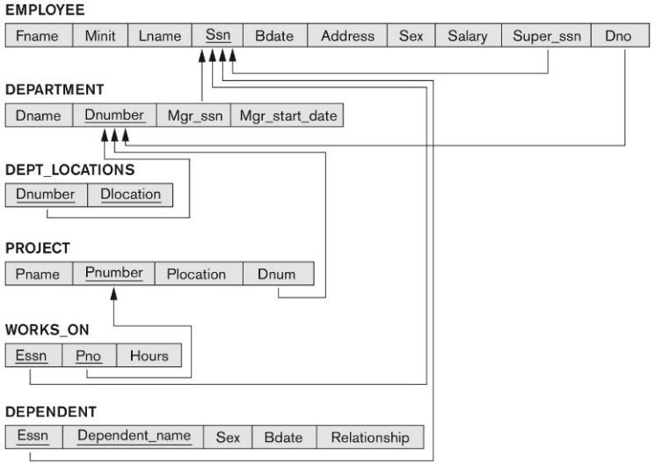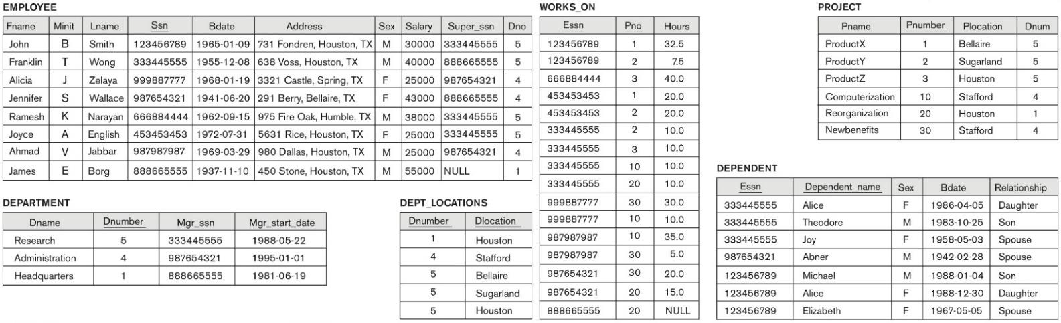

1. **(15 pts)** Consider following relations for a database. Specify the foreign keys and referential integrity constraints for this schema.

|  |  |  |  |  |
| --- | --- | --- | --- | --- |
| **DRAGON_ BALL_Z_CHARACTER** | | | | |
| Name | Power_Level | Species_Type | IsStrongerThanKrillin | NumberOfDeaths |

|  |  |  |  |
| --- | --- | --- | --- |
| **SAIYAN_ABILITY** | | |  |
| DBZ_Name | ssj1Flag | ssj2Flag | ssj3Flag |

# SPECIES

|  |  |  |
| --- | --- | --- |
| Type | Home_Planet | RiskOfExtinction |

|  |  |  |
| --- | --- | --- |
| **SAGA** | | |
| Main_Enemy | Battle_Planet | Enemy_Species_Type |

1. **(15 pts)** Map the following EER diagram to a relational schema. Define primary keys, foreign keys, and show referential integrity constraints.

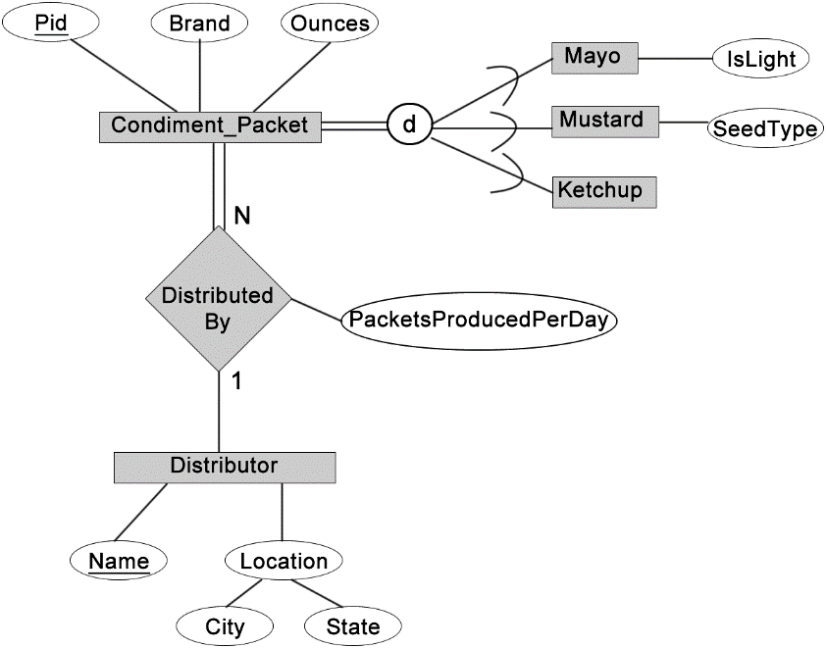

1. **(15 pts)** Using relational algebra operations, construct a query that satisfies the provided description. Show the resulting relation (table with tuples). Database state is provided for your reference.
   1. Retrieve the birthdate of all employees whose salary is under $31,000 and have worked on ProductX.
   2. Retrieve the Address of all employees who work in the Administration department and have at least one dependent.

